1. Write Testable Code with Moq :

CustomerCommLib / MailSender.cs

using System.Net;
using System.Net.Mail;

namespace CustomerCommLib
{
public interface IMailSender
{
bool SendMail(string toAddress, string message);
}

public class MailSender : IMaiSender
{
public bool SendMail(string toAddress, string message)
{
MailMessage mail = new MailMessage();
SmtpClient SmtpServer = new SmtpClient("smtp.gmail.com");

mail.From = new MailAddress("your_email_address@gmail.com");
mail.To.Add(toAddress);
mail.Subject = "Test Mail";
mail.Body = message;

SmtpServer.Port = 587;
SmtpServer.Credentials = new NetworkCredential("username", "password");
SmtpServer.EnableSsl = true;

SmtpServer.Send(mail);
return true;
}
}

public class CustomerComm
{
IMailSender _mailSender;

public CustomerComm(IMailSender mailSender)
{
_mailSender = mailSender;
}

public bool SendMailToCustomer()
{
_mailSender.SendMail("cust123@abc.com", "Some Message");
return true;
}
}
}

CustomerComm.Tests/CustomerCommTests.cs

using Moq;
using NUnit.Framework;
using CustomerCommLib;

namespace CustomerComm.Tests
{
[TestFixture]
public class CustomerCommTests
{
private Mock<IMailSender> _mockMailSender;
private CustomerCommLib.CustomerComm _customerComm;

[OneTimeSetUp]
public void Setup()
{
_mockMailSender = new Mock<IMailSender>();
_mockMailSender.Setup(x => x.SendMail(It.IsAny<string>(), It.IsAny<string>())).Returns(true);
_customerComm = new CustomerCommLib.CustomerComm(_mockMailSender.Object);
}

[Test]
public void SendMailToCustomer_ShouldReturnTrue()
{
bool result = _customerComm.SendMailToCustomer();
Assert.IsTrue(result);
}
}
}

- Output:

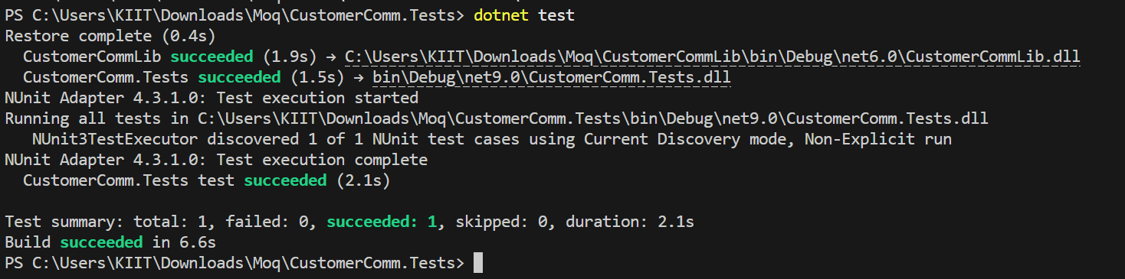

Mock file object for Unit Tests :

MagicFilesLib/DirectoryExplorer.cs

using System.Collections.Generic;
using System.IO;

namespace MagicFilesLib
{
public interface IDirectoryExplorer
{
ICollection<string> GetFiles(string path);
}

public class DirectoryExplorer : IDirectoryExplorer
{
public ICollection<string> GetFiles(string path)
{
string[] files = Directory.GetFiles(path);
return files;
}
}
}

DirectoryExplorer.Tests/DirectoryExplorerTests.cs

using Moq;
using NUnit.Framework;
using MagicFilesLib;
using System.Collections.Generic;

namespace DirectoryExplorer.Tests
{
[TestFixture]
public class DirectoryExplorerTests
{
private readonly string _file1 = "file.txt";
private readonly string _file2 = "file2.txt";
private IDirectoryExplorer _directoryExplorer;
[OneTimeSetUp]
public void Setup()
{
var mock = new Mock<IDirectoryExplorer>();
mock.Setup(x => x.GetFiles(It.IsAny<string>())).Returns(new List<string> { _file1, _file2 });
_directoryExplorer = mock.Object;
}
[Test]
public void GetFiles_ShouldReturnTwoFiles()
{
var files = _directoryExplorer.GetFiles("dummyPath");
Assert.IsNotNull(files);
Assert.AreEqual(2, files.Count);
Assert.Contains(_file1, (System.Collections.ICollection)files);
}
}
}

- Output:

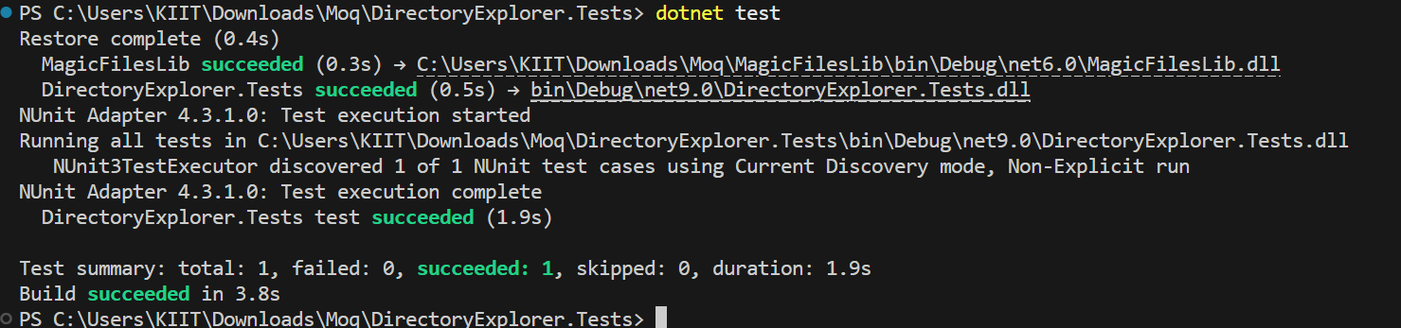

Mock database for Unit Tests :

PlayersManagerLib/PlayerManager.cs

using System;
using System.Data.SqlClient;

namespace PlayersManagerLib
{
public interface IPlayerMapper
{
bool IsPlayerNameExistsInDb(string name);
void AddNewPlayerIntoDb(string name);
}

public class PlayerMapper : IPlayerMapper
{
private readonly string _connectionString = "Data Source=(local);Initial Catalog=GameDB;Integrated Security=True";

public bool IsPlayerNameExistsInDb(string name)
{
using (SqlConnection conn = new SqlConnection(_connectionString))
{
conn.Open();
using (SqlCommand cmd = conn.CreateCommand())
{
cmd.CommandText = "SELECT COUNT(*) FROM Player WHERE Name = @name";
cmd.Parameters.AddWithValue("@name", name);
return (int)cmd.ExecuteScalar() > 0;
}
}
}

public void AddNewPlayerIntoDb(string name)
{
using (SqlConnection conn = new SqlConnection(_connectionString))
{
conn.Open();
using (SqlCommand cmd = conn.CreateCommand())
{
cmd.CommandText = "INSERT INTO Player (Name) VALUES (@name)";
cmd.Parameters.AddWithValue("@name", name);
cmd.ExecuteNonQuery();
}
}
}
}

public class Player
{
public string Name { get; private set; }
public int Age { get; private set; }
public string Country { get; private set; }
public int NoOfMatches { get; private set; }

public Player(string name, int age, string country, int matches)
{
Name = name;
Age = age;
Country = country;
NoOfMatches = matches;
}

public static Player RegisterNewPlayer(string name, IPlayerMapper playerMapper = null)
{
playerMapper ??= new PlayerMapper();

if (string.IsNullOrWhiteSpace(name))
throw new ArgumentException("Player name can’t be empty.");

if (playerMapper.IsPlayerNameExistsInDb(name))
throw new ArgumentException("Player name already exists.");

playerMapper.AddNewPlayerIntoDb(name);
return new Player(name, 23, "India", 30);
}
}
}

PlayerManager.Tests/PlayerManagerTests.cs

using Moq;
using NUnit.Framework;
using PlayersManagerLib;
using System;

namespace PlayerManager.Tests
{
[TestFixture]
public class PlayerManagerTests
{
private Mock<IPlayerMapper> _mockMapper;

[OneTimeSetUp]
public void Setup()
{
_mockMapper = new Mock<IPlayerMapper>();
_mockMapper.Setup(x => x.IsPlayerNameExistsInDb(It.IsAny<string>())).Returns(false);
}

[Test]
public void RegisterNewPlayer_ShouldReturnPlayerObject()
{
var player = Player.RegisterNewPlayer("Dhoni", _mockMapper.Object);
Assert.AreEqual("Dhoni", player.Name);
Assert.AreEqual(23, player.Age);
Assert.AreEqual("India", player.Country);
Assert.AreEqual(30, player.NoOfMatches);
}
}
}

- Output:

